***(A)***

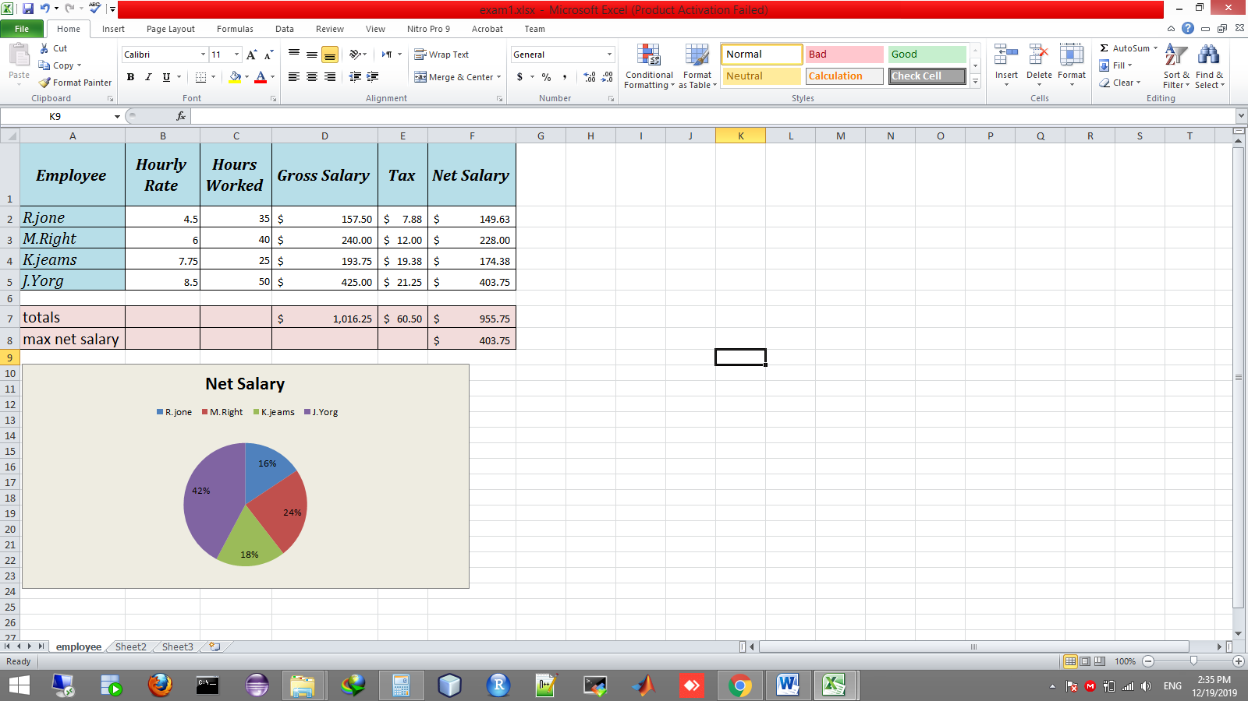**Question 2 (Excel):**

1. Create “employee_A” worksheet as shown above.(2 marks)
2. Calculate Gross salary for all employees (Gross salary=Hourly Rate*Hours worked). (1 marks)
3. Calculate 10% Tax for all employees whose gross salary is greater than 200$ otherwise 5% (Tax=Gross salary*tax percentage/100). (2 marks)
4. Calculate net salary for all employees (net salary=gross salary-tax). (1 marks)
5. Calculate total gross salary, tax, and net salary. (1 marks)
6. Find max net salary. (1 marks)
7. Create pie chart using employee column and net salary. (2 marks)